## **ANGULAR FRONTEND**

1. **Registration page**

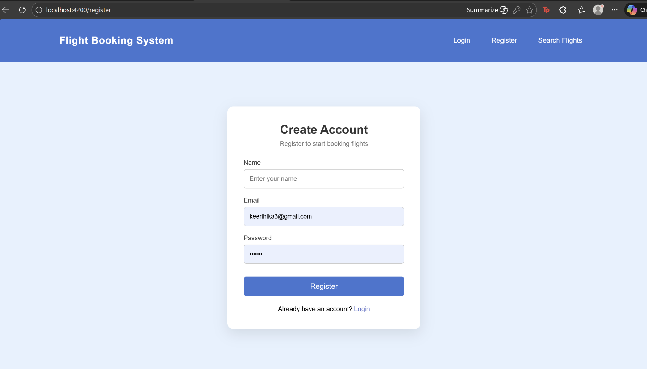

1. **Registered Successfully**

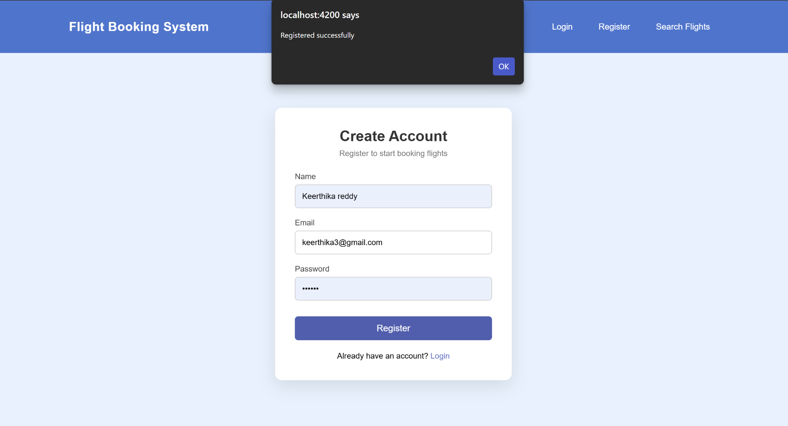

1. **Login page**

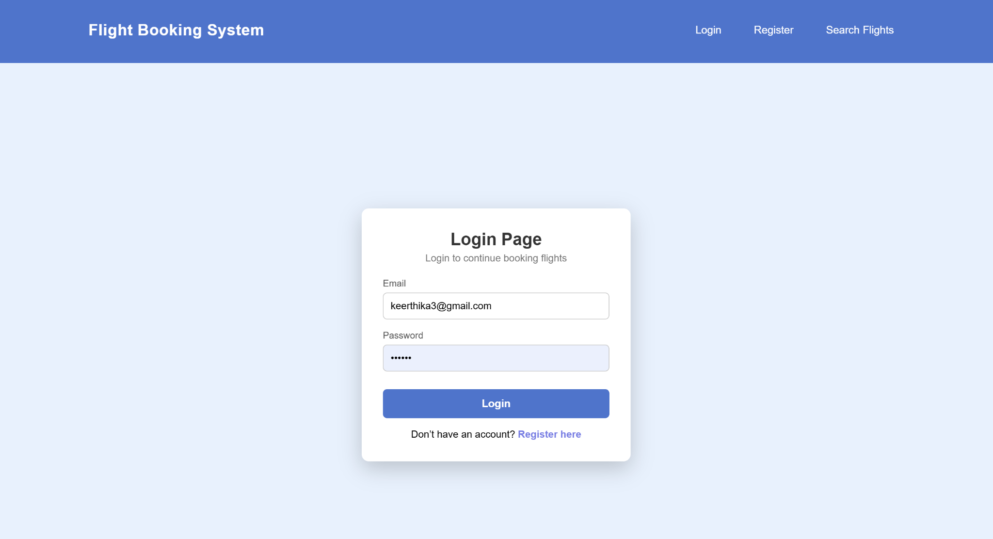

1. **Flight-search page**

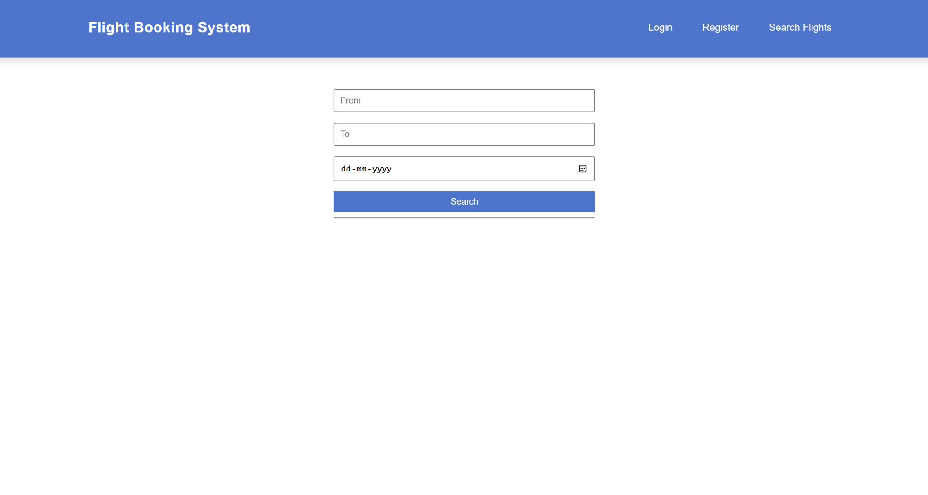

1. **Flight-search successful**

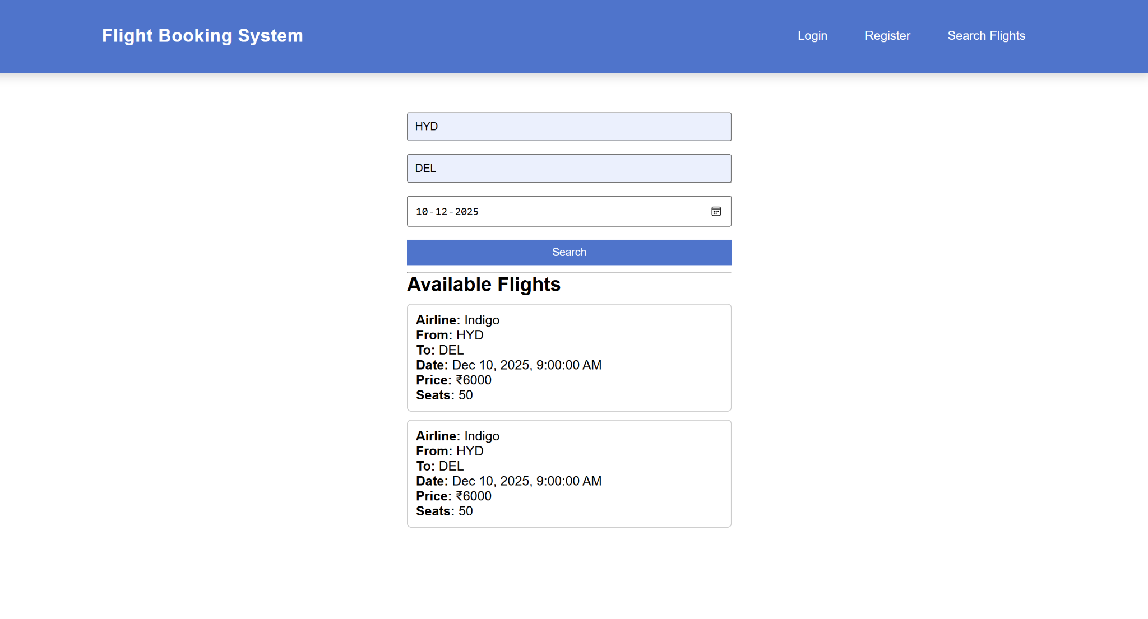

## **MONGODB COLLECTIONS**

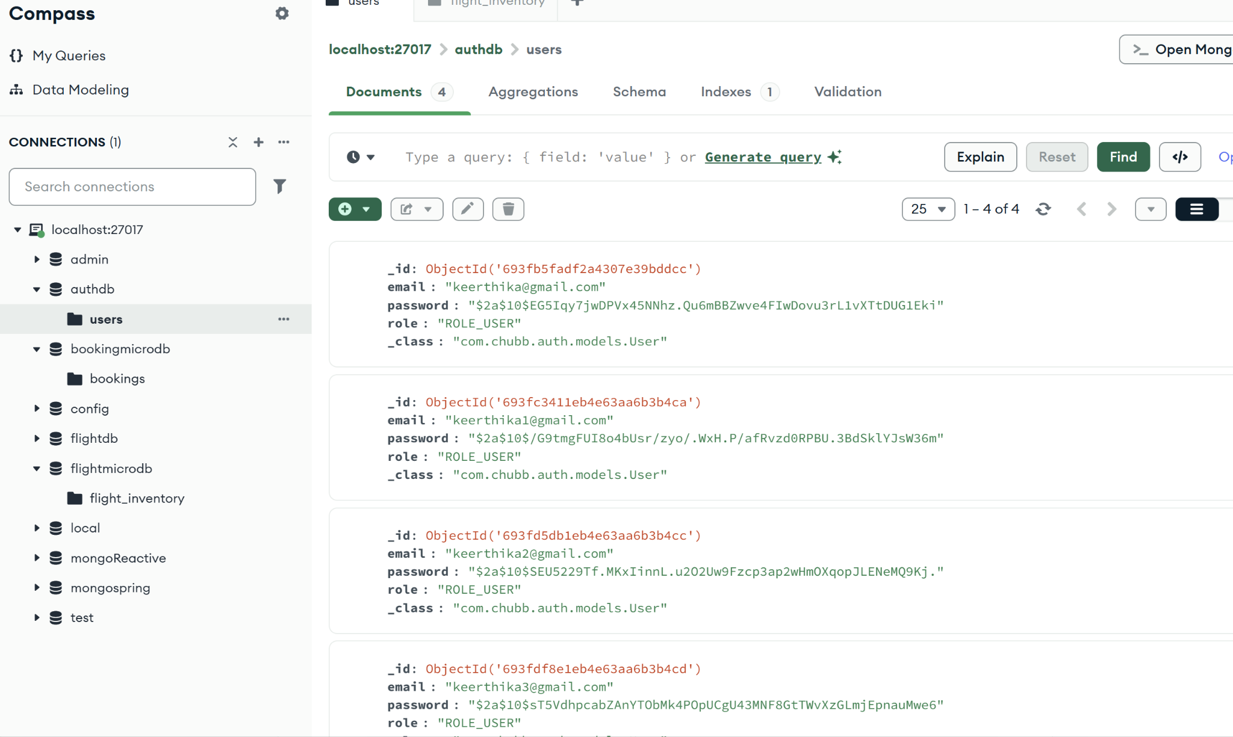

**Docker Execution**

1. **Docker Containers (Docker desktop)**

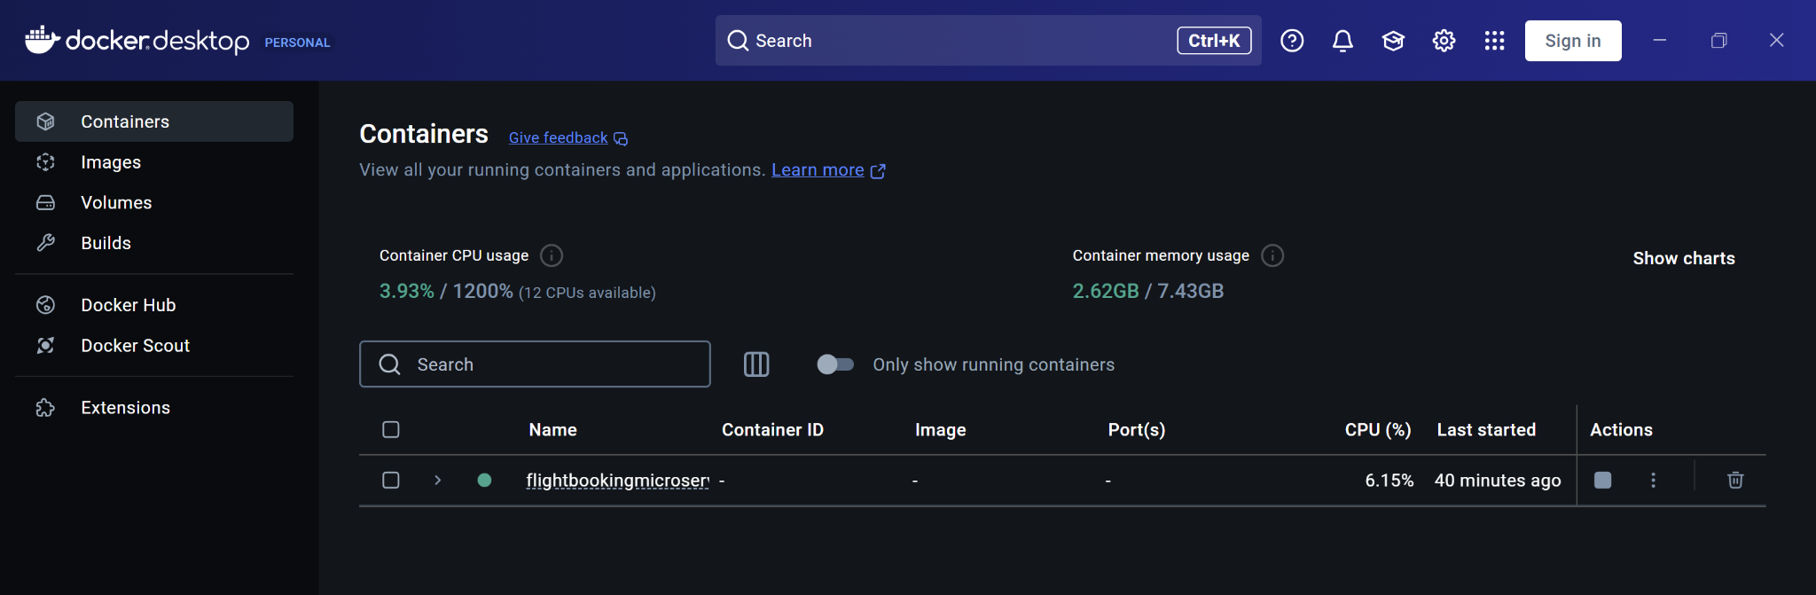

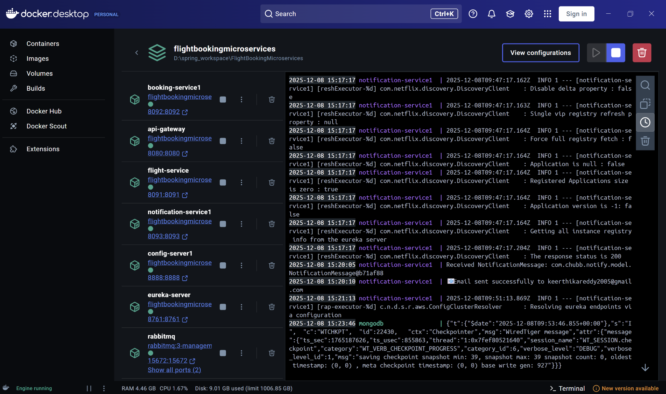

1. **Docker ps**

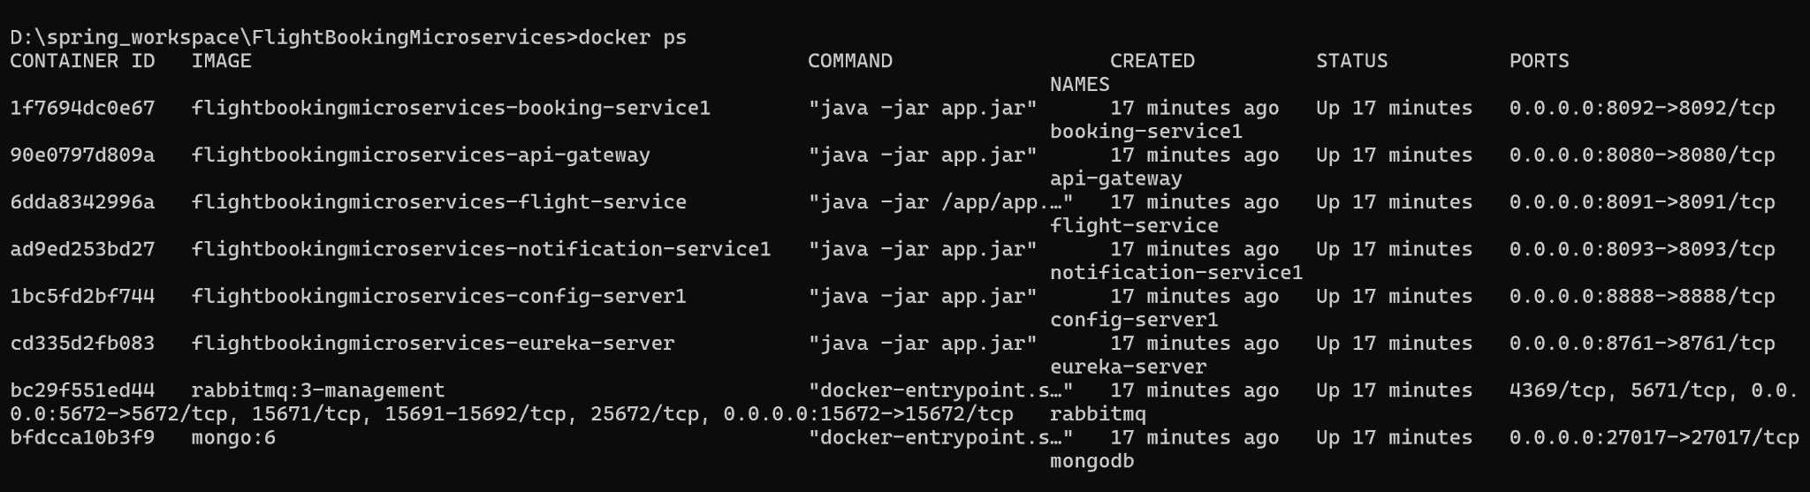

1. **Docker logs**

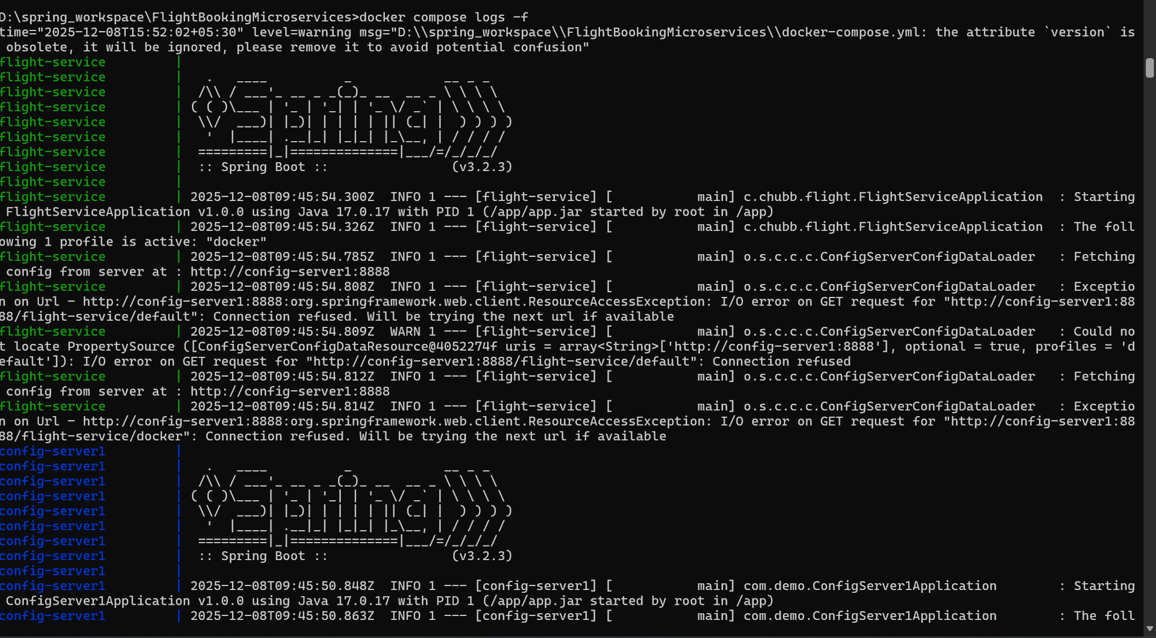

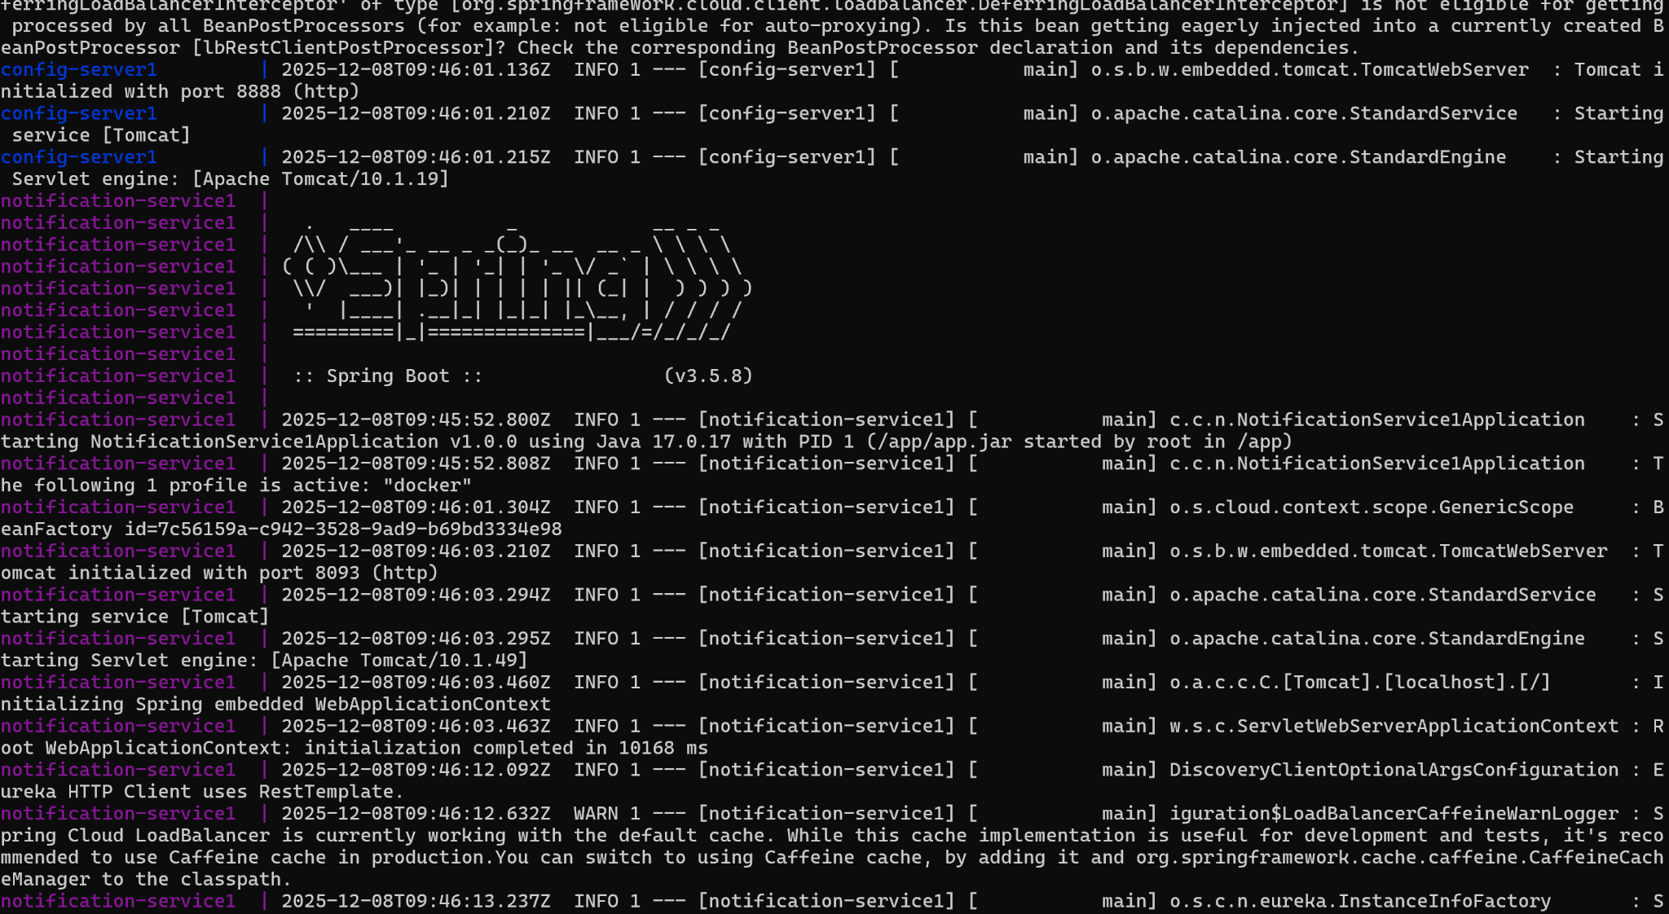

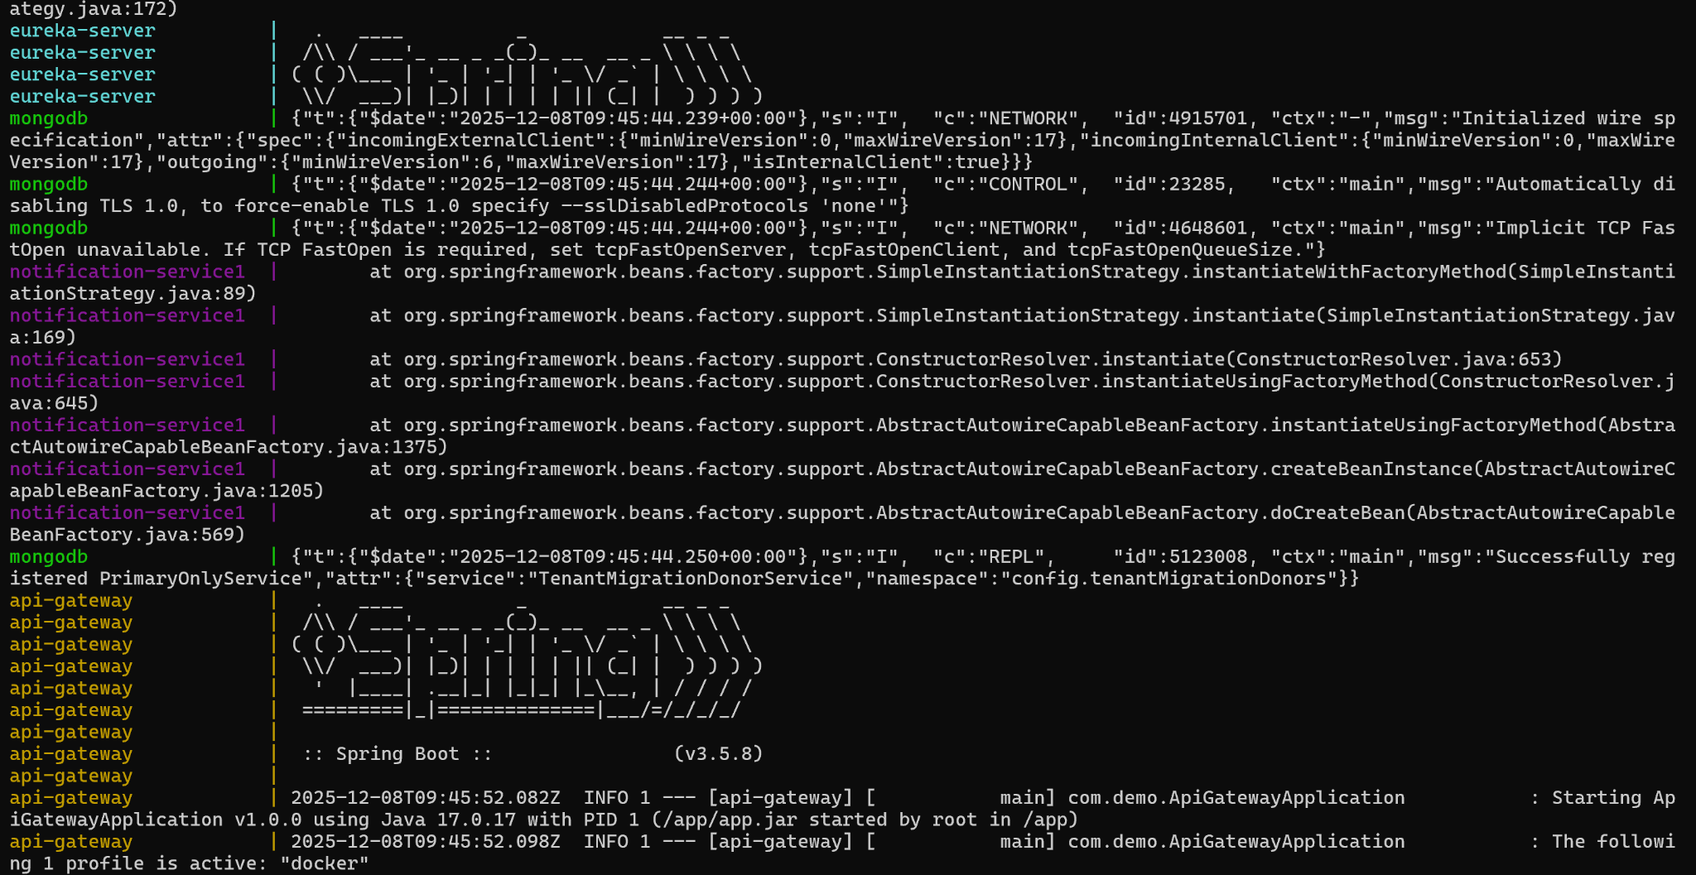

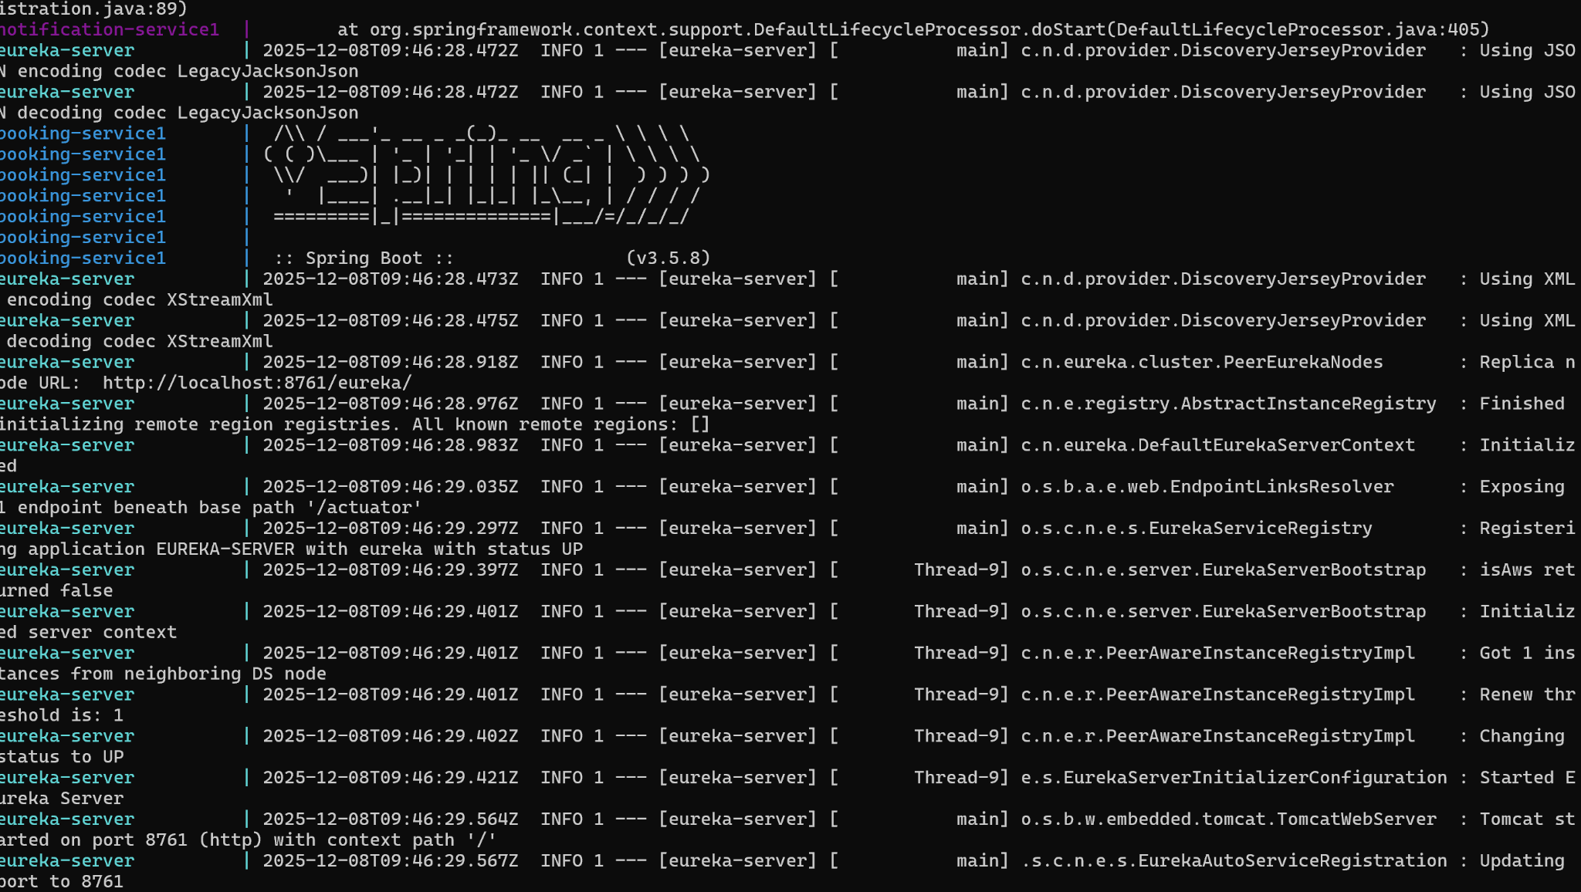

**Service Dashboard**

1. **Eureka Server Dashboard**

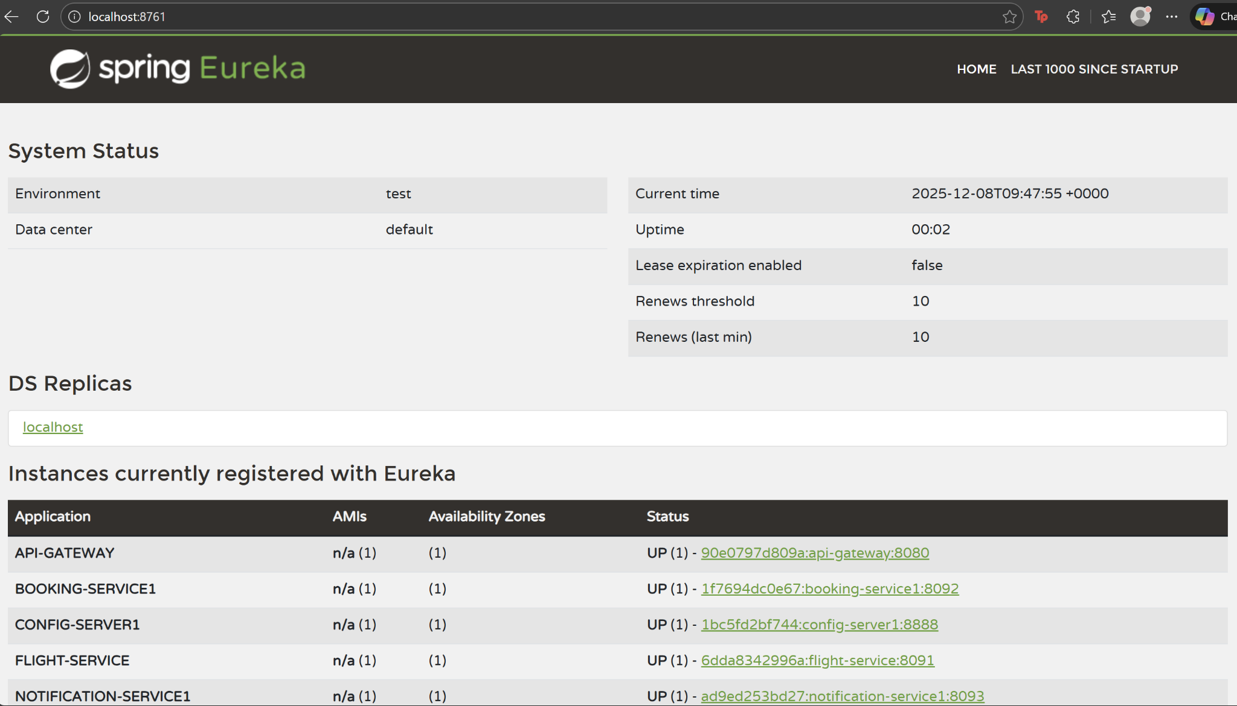

1. **Config Server Console (booking-service)**

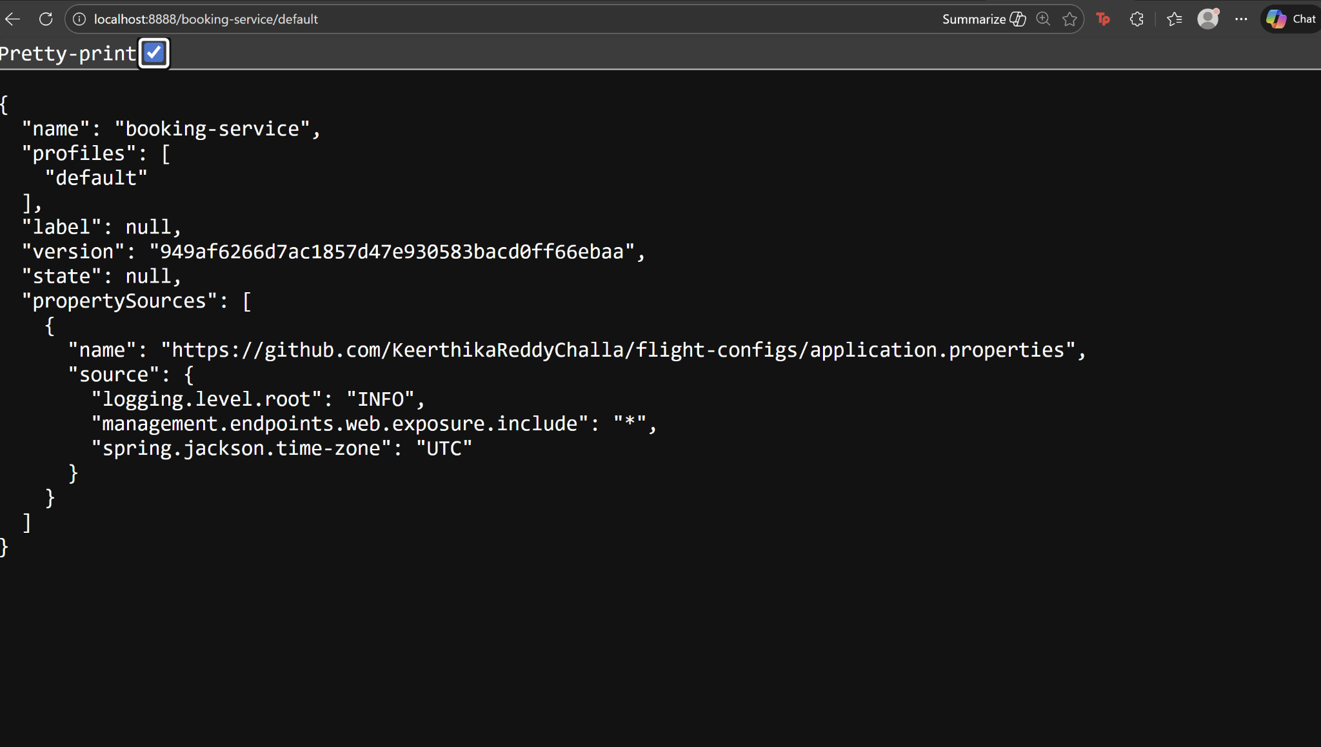

1. **Config Server Console (flight-service)**

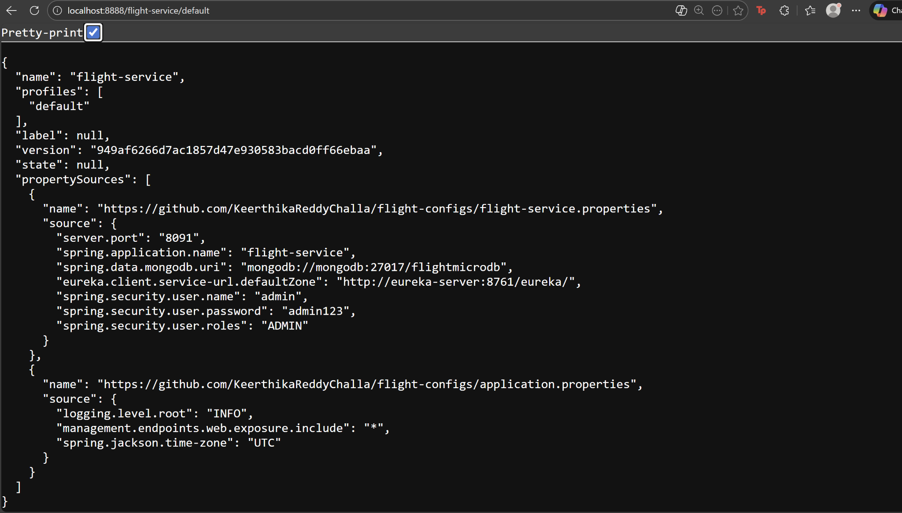

1. **Config Server Console (api-gateway)**

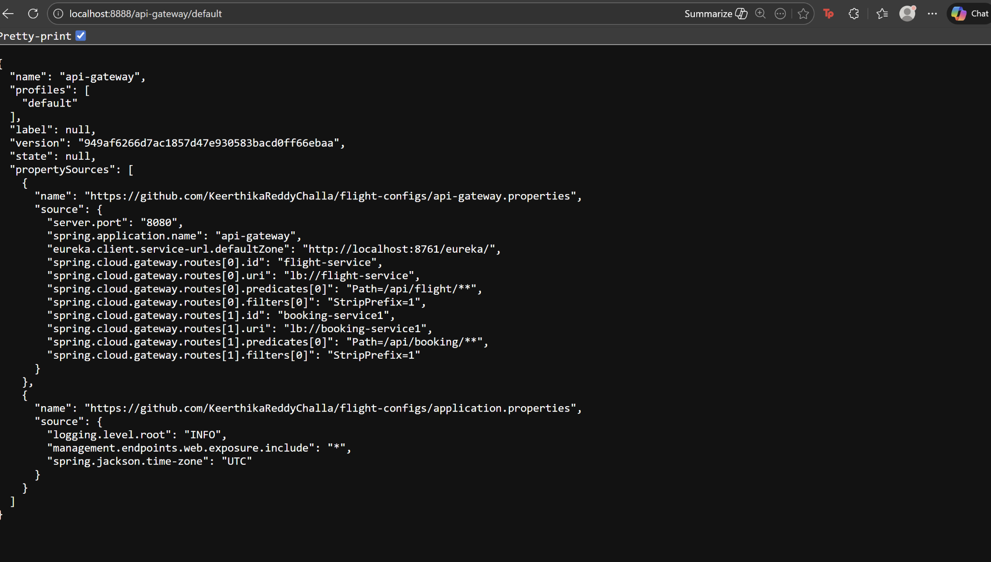

1. **Config Server Console (notification-service)**

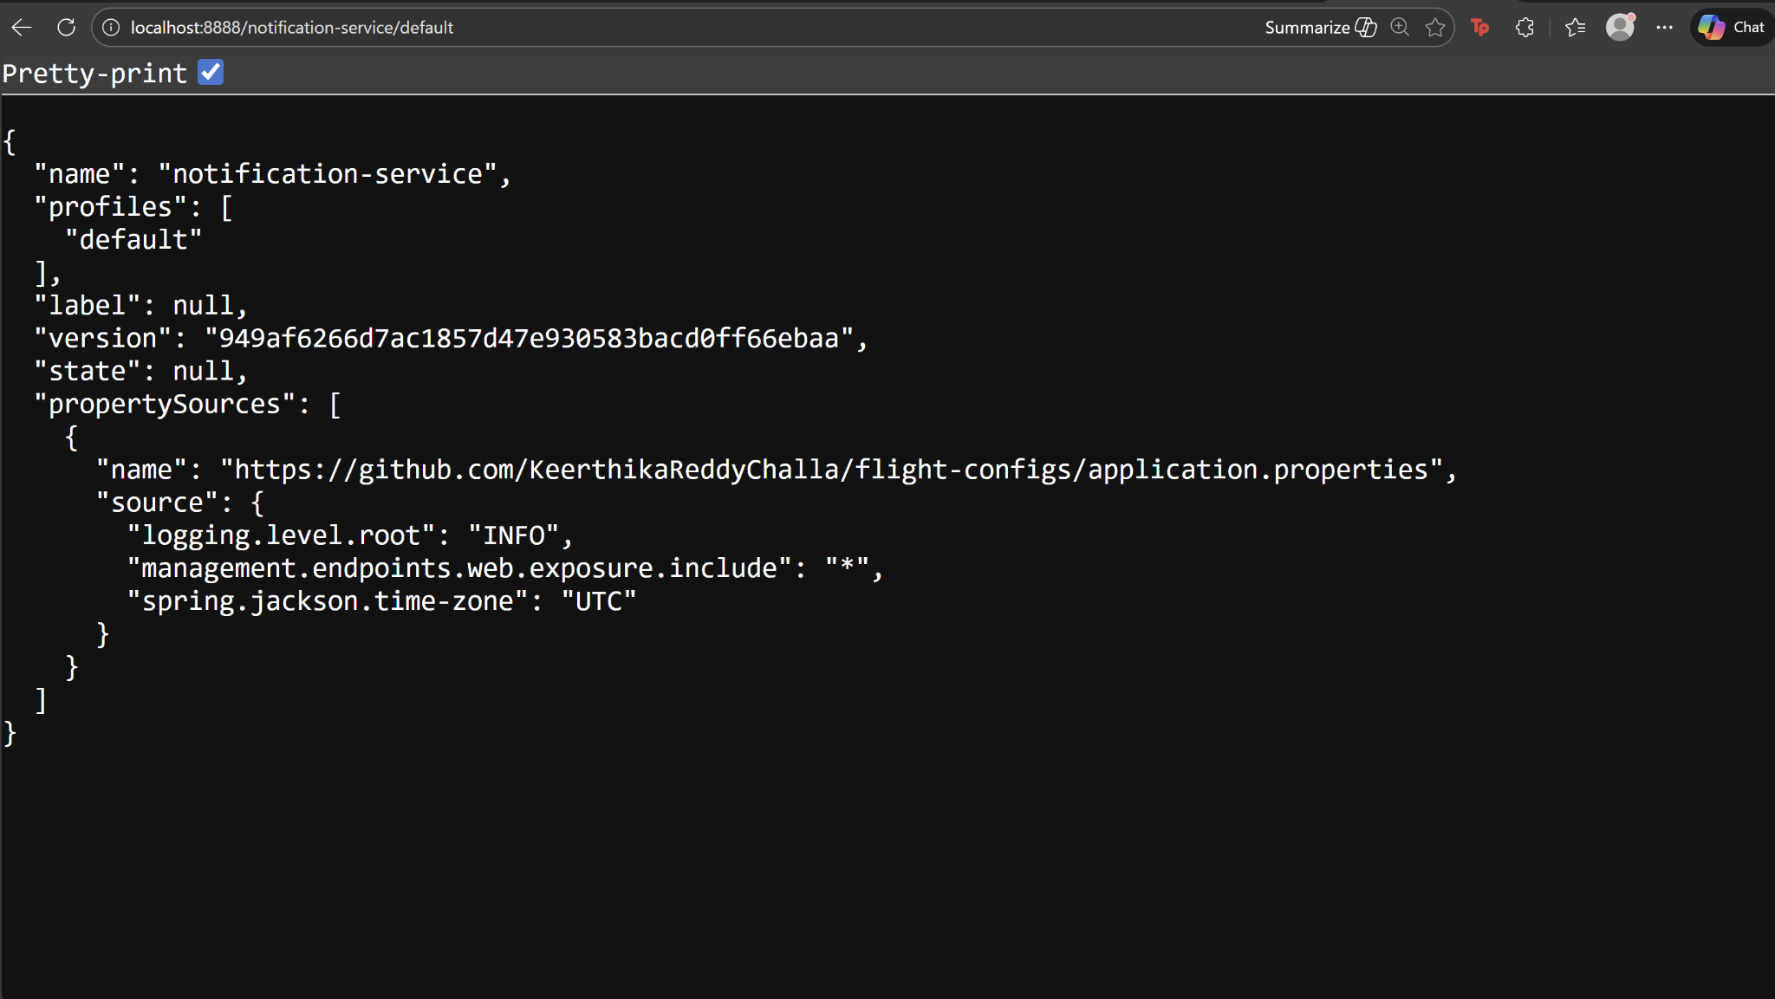

1. **flight-configs (git repository)**

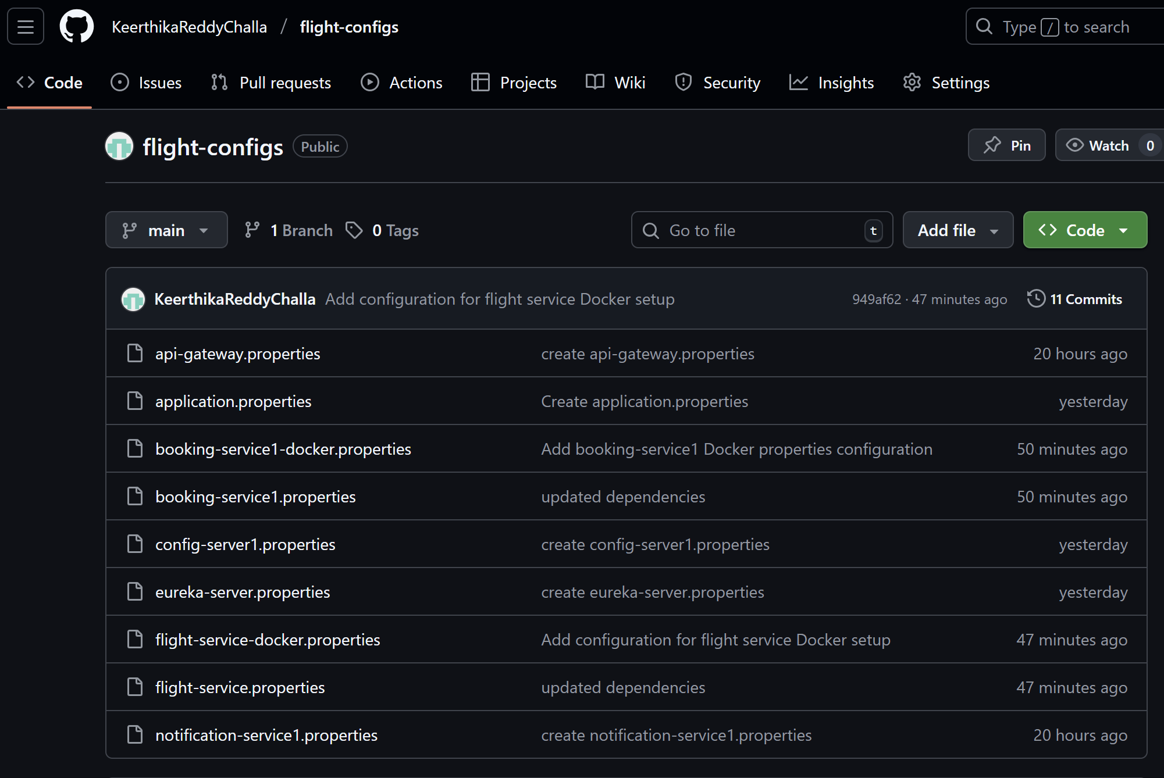

**Notification-Service (RabbitMQ + Email)**

1. **RabbitMQ Dashboard**

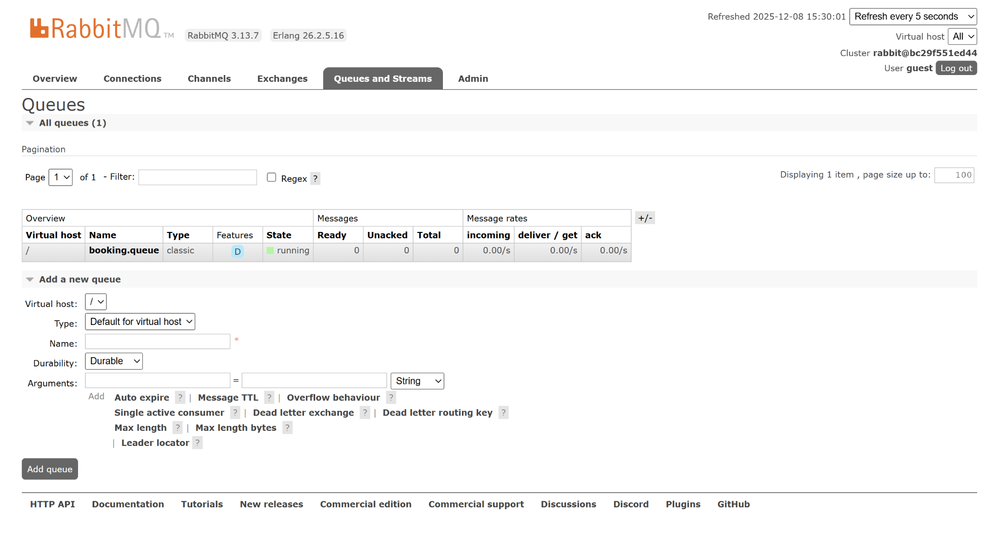

1. **Booking confirmation email**

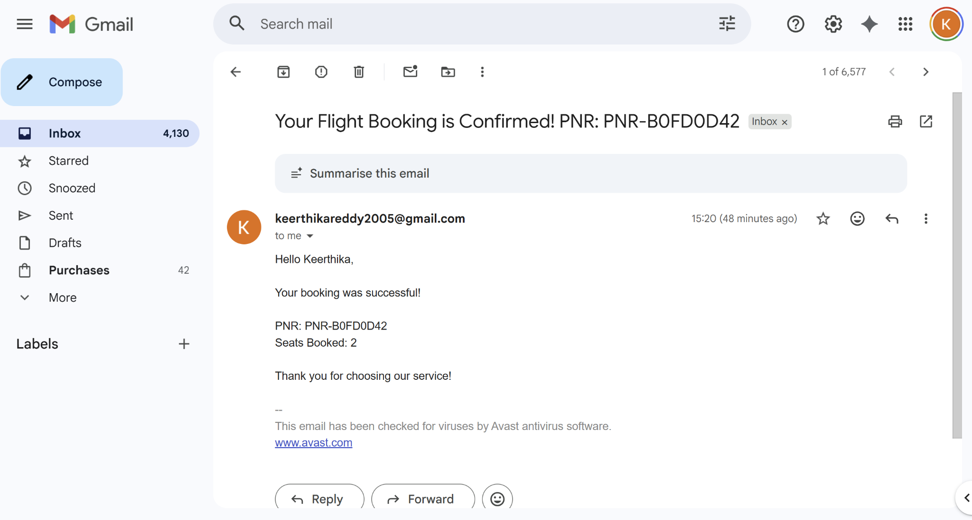

1. **Notification-service success log**

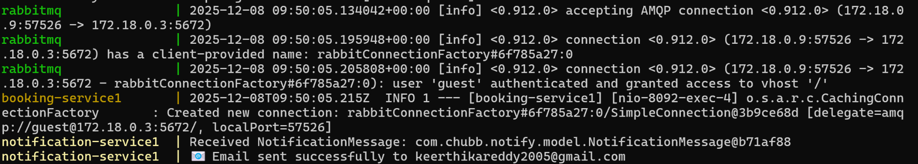

**Spring Security**

1. **Admin authentication**

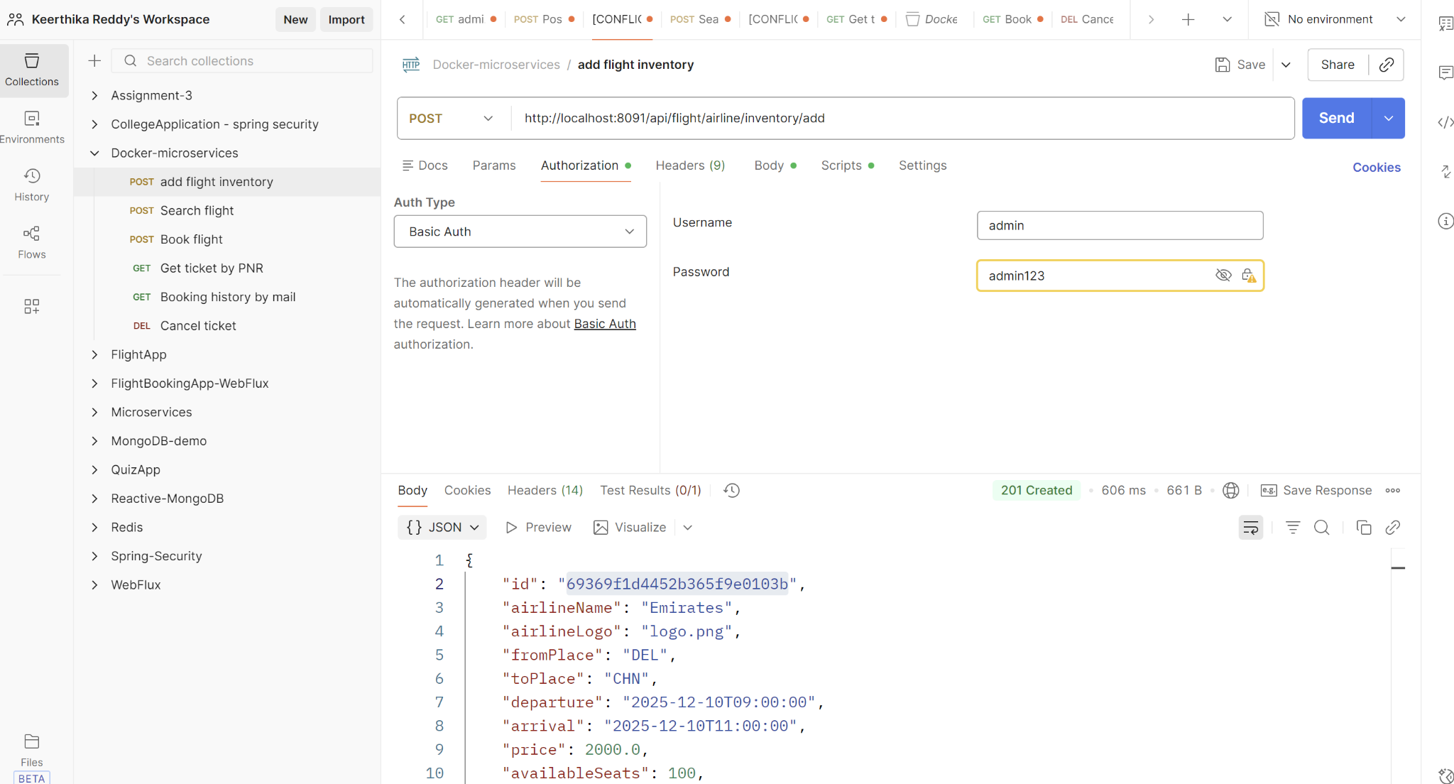

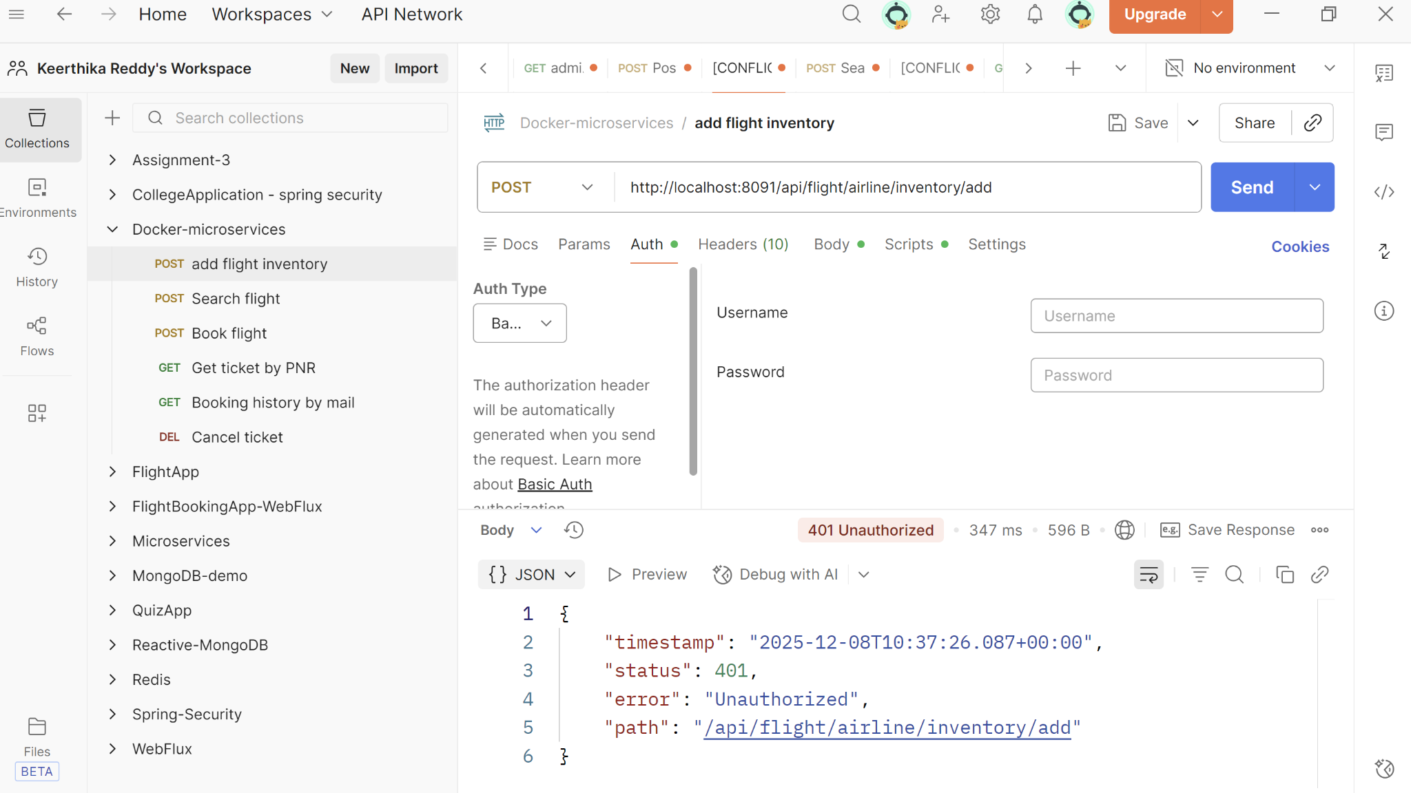

1. **User authentication**

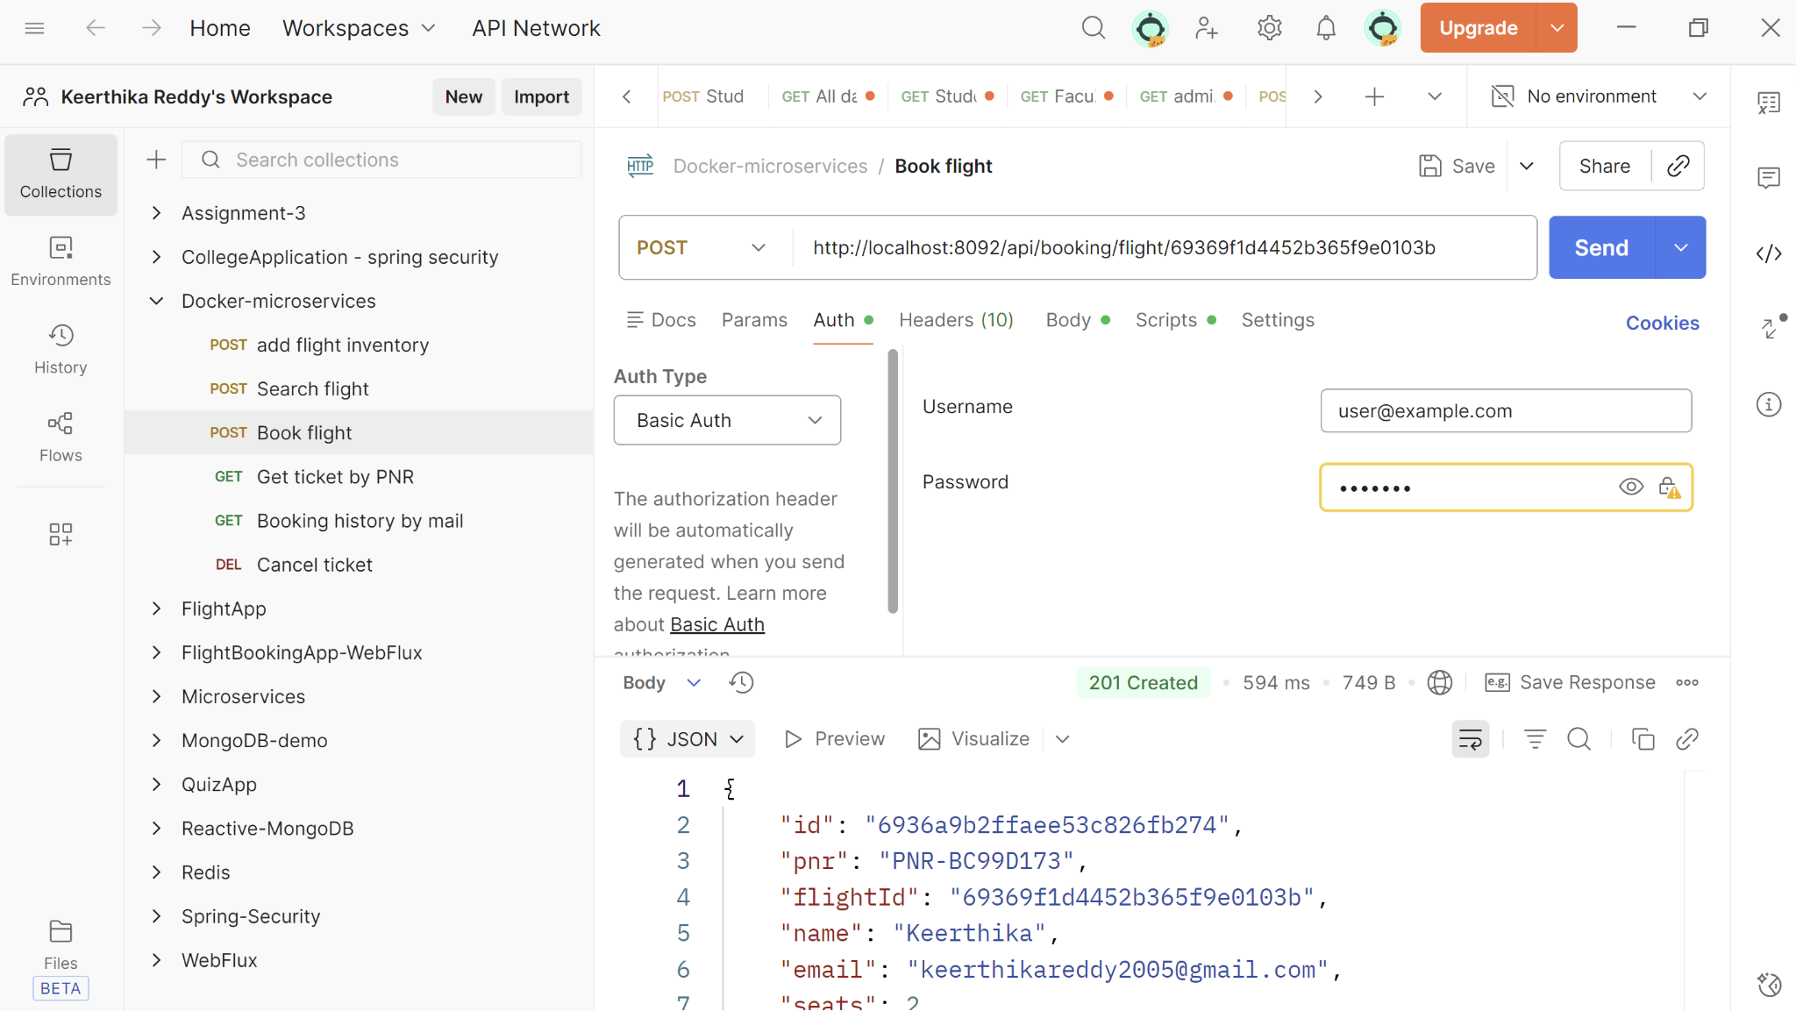

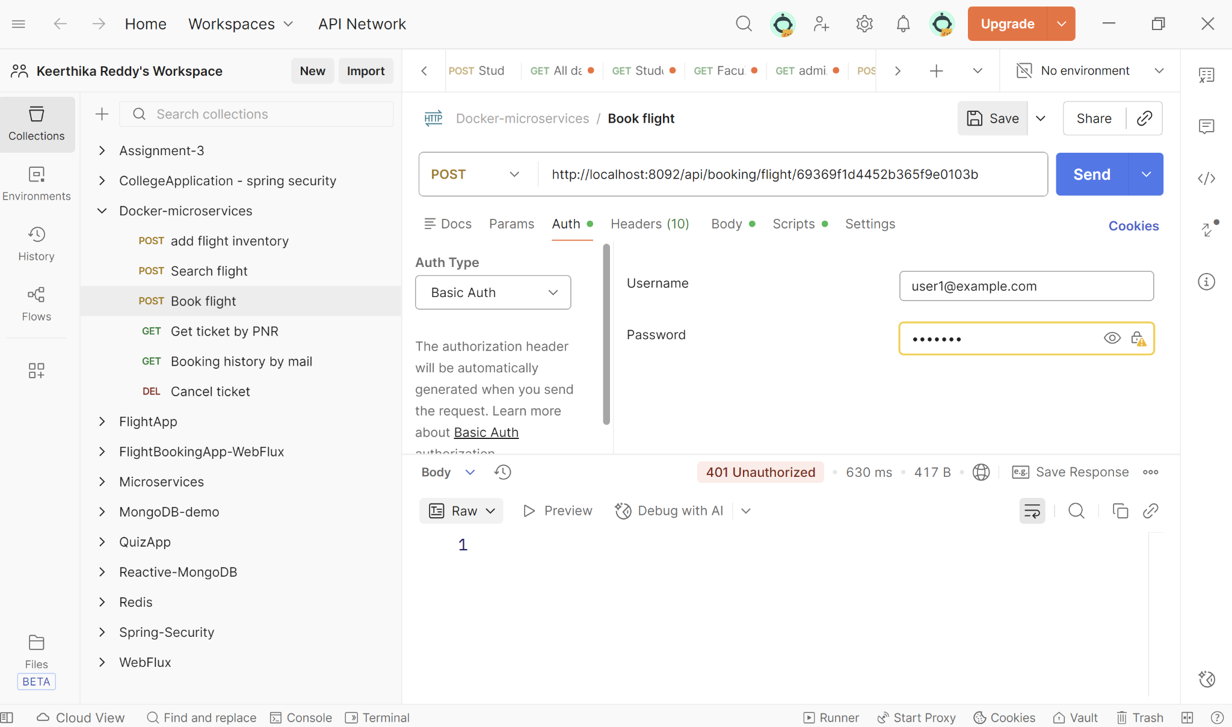

**Swagger API Documentation**

1. **Flight-service API documentation**

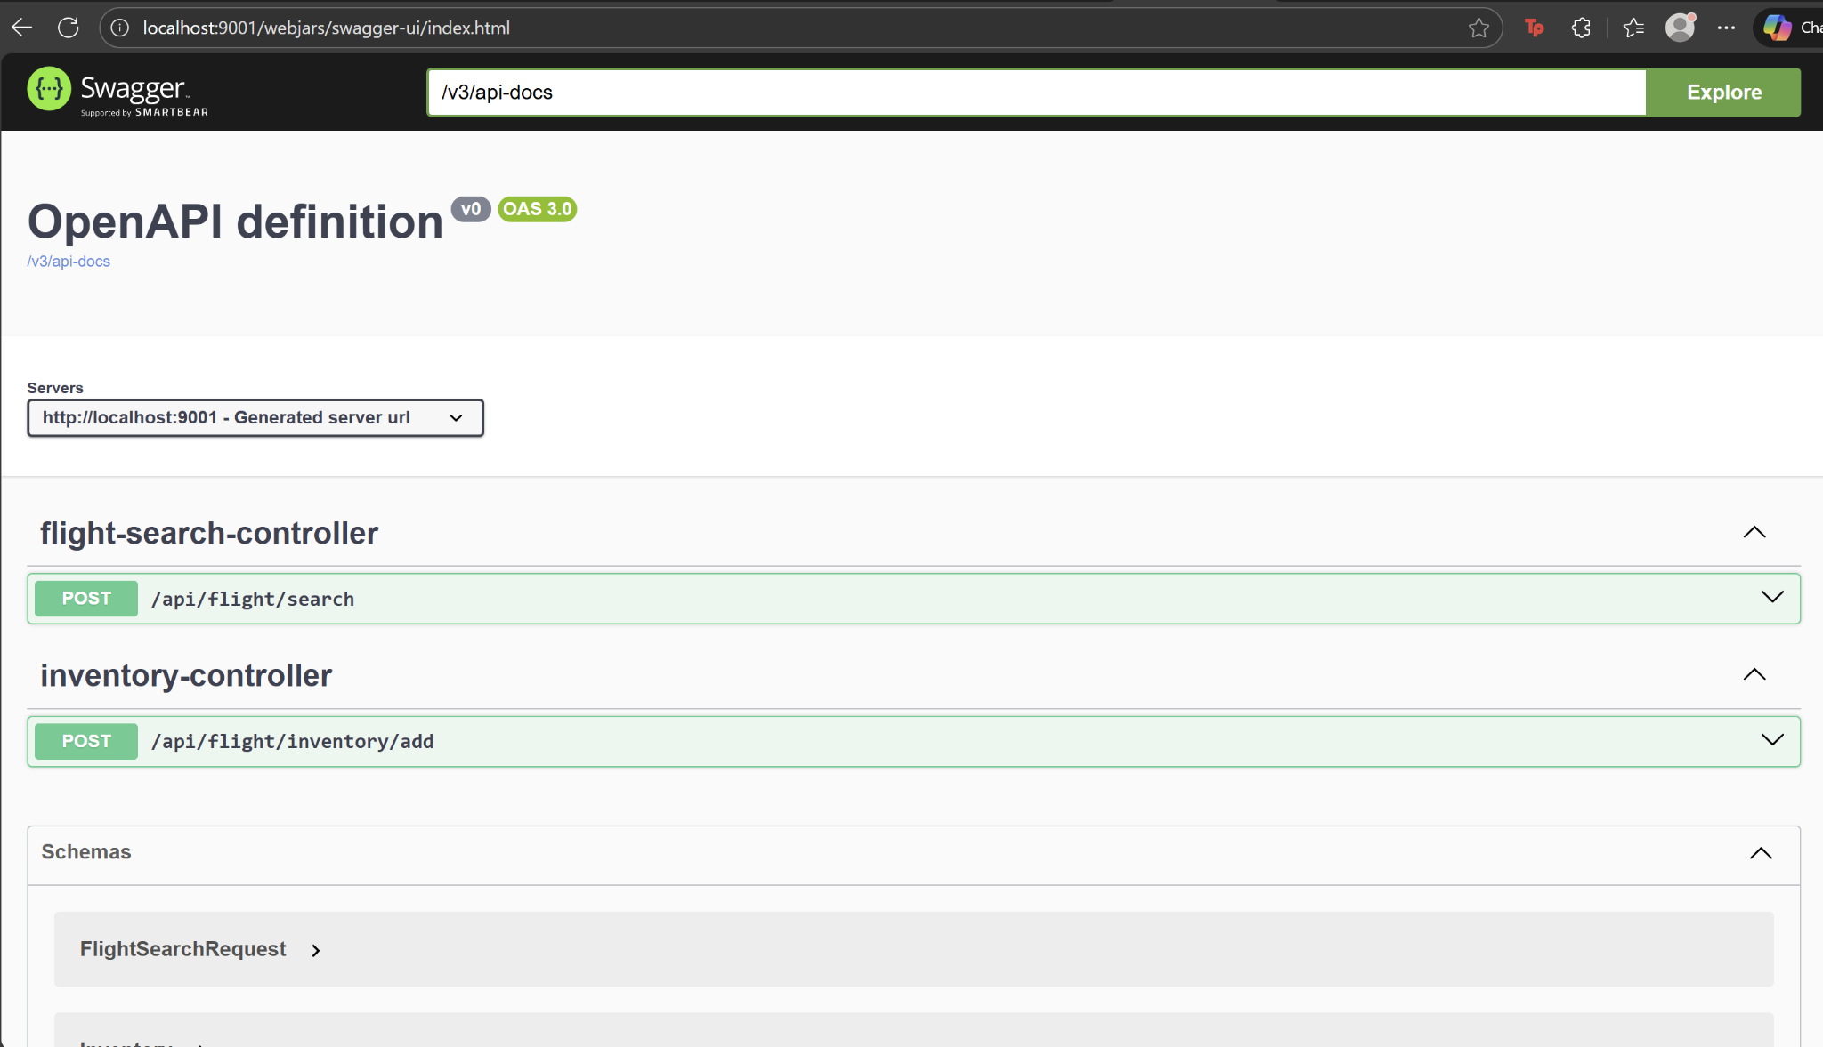

1. **Booking-service API documentation**

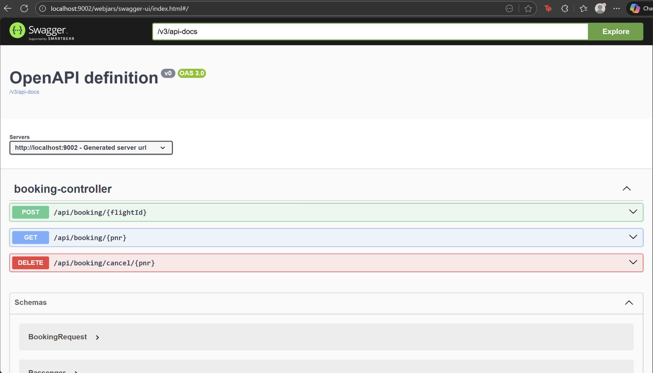

**Performance Evaluation using JMeter**

1. **Jmeter Results tree**

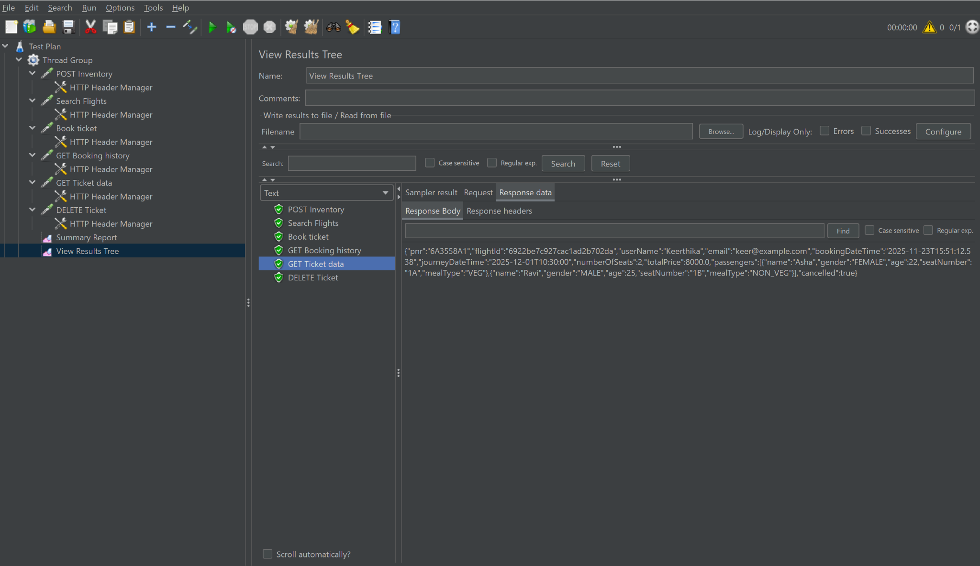

1. **Jmeter Summary-report (1-sample)**

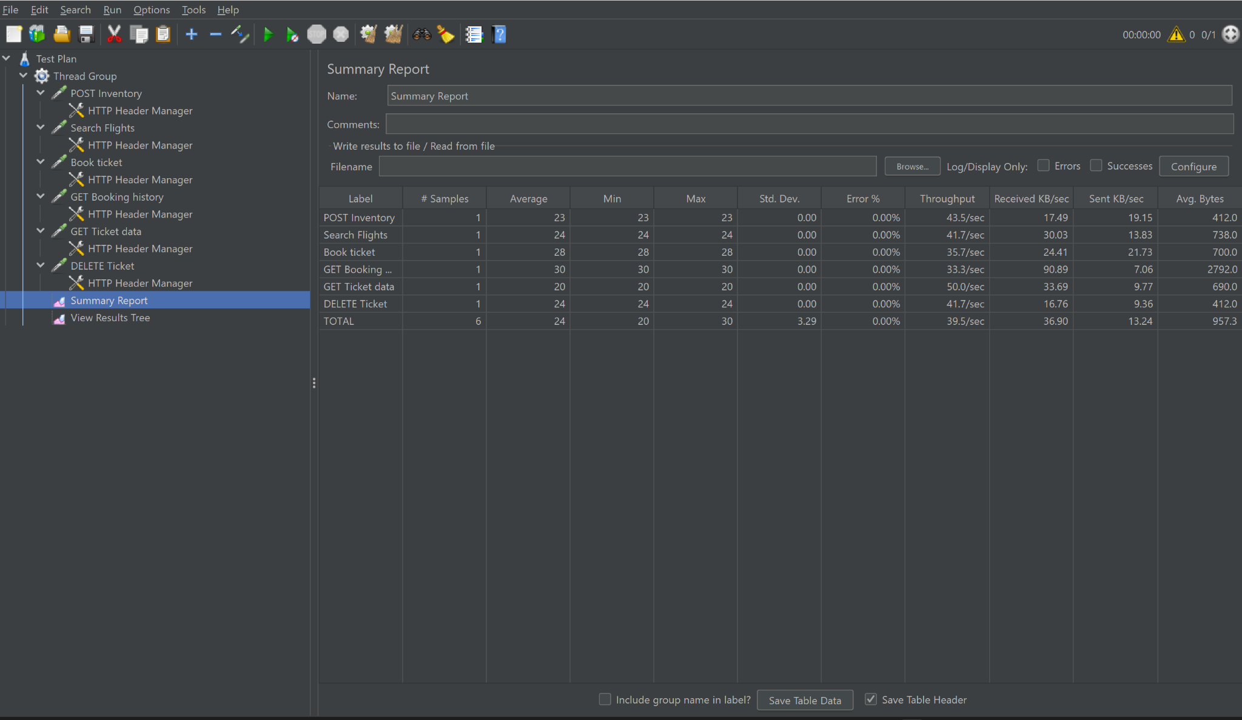

1. **Jmeter Summary-report (20-samples)**

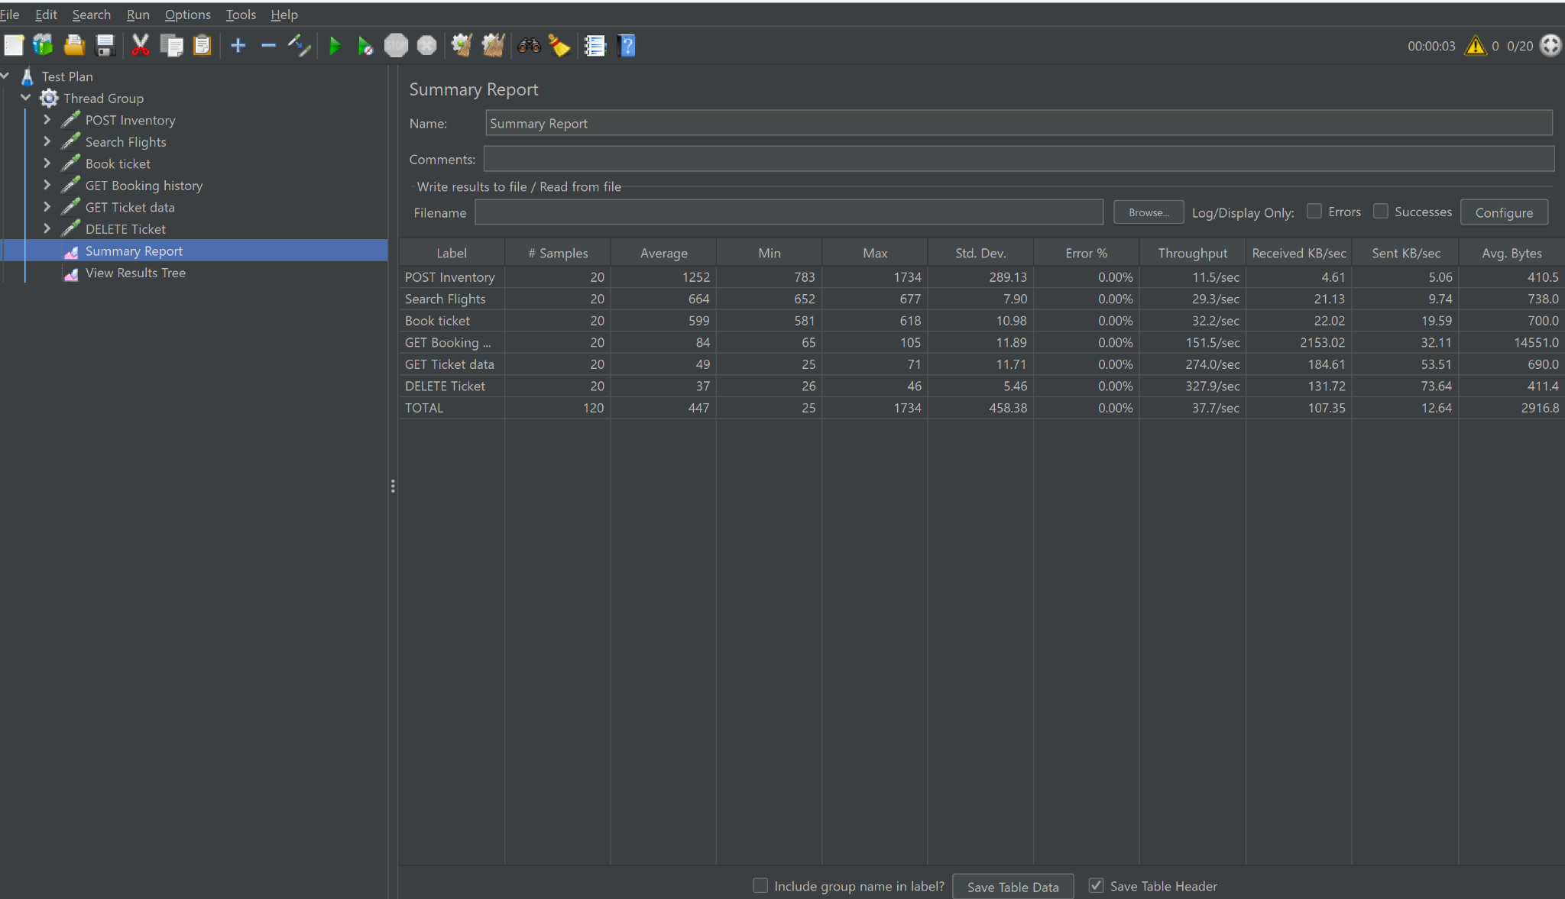

**Jacoco Test coverage report**

1. **Flight-Service JaCoCo Report**

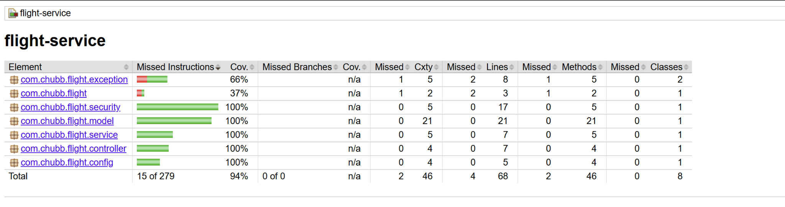

1. **Booking-Service JaCoCo Report**

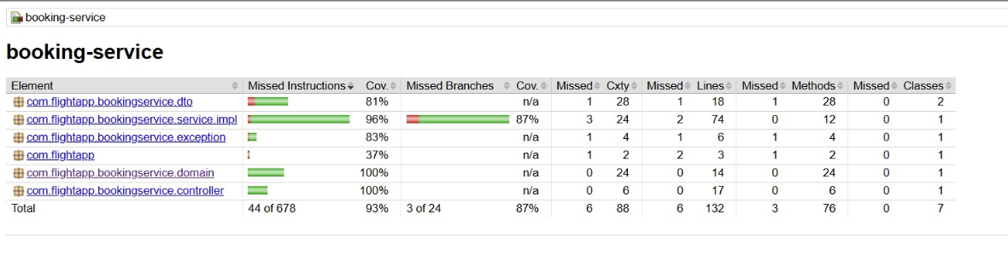

**Code Coverage using SonarCloud**

